PAXTracer


Technical description
PAXTracer software is associated with one or more boarding pass readers (in security check point, boarding area, VIP lounge, etc.), allowing the airport to have real time monitoring of each passenger and obtain statistics on transit time between each control point.
The information is collected from the boarding cards of passengers.
The software "PAX Tracer" uses various checkpoints points for data collection:
- at Check-in- if the stations are either equipped with barcode reader (BC) or boarding pass reader card reader (BG) ;
- at Boarding - if the stations are either equipped with barcode reader (BC) or boarding card reader (BG).

Other data collection points can be set up. We must add one or more of the following equipment
- PAXTracer stations equipped with barcode readers (2D, QR code, etc.);
- one or more automatic gates.

Functional description
The user just presents the boarding pass or smartphone of passenger to an integrated barcode reader and system checks the validates the travel ticket.
It is then stored in PAXTracer database.

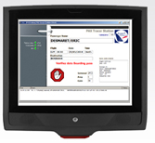
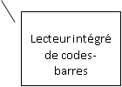
Integrated Bar Code Reader
Integrated Bar Code Reader

The data is available and, depending on the number of PAXTracer stations and their position, the program provides the following information:
- passenger search to locate him in the terminal;
- list and number of passengers in a given area:
  - in security filter,
  - in VIP lounge,
  - in boarding area.
- calculating the average time between two PAXTracer points.
For example: Calculation of the average crossing time at the security filter;
- statistics on the final destinations of transit passengers.

Reading boarding passes
The user presents the passenger’s boarding pass to integrated barcode reader and data is collected by the system.
In the example below, the passenger is denied because the date on boarding card is incorrect. All anomalies are stored in the PAXTracer database for analysis later.
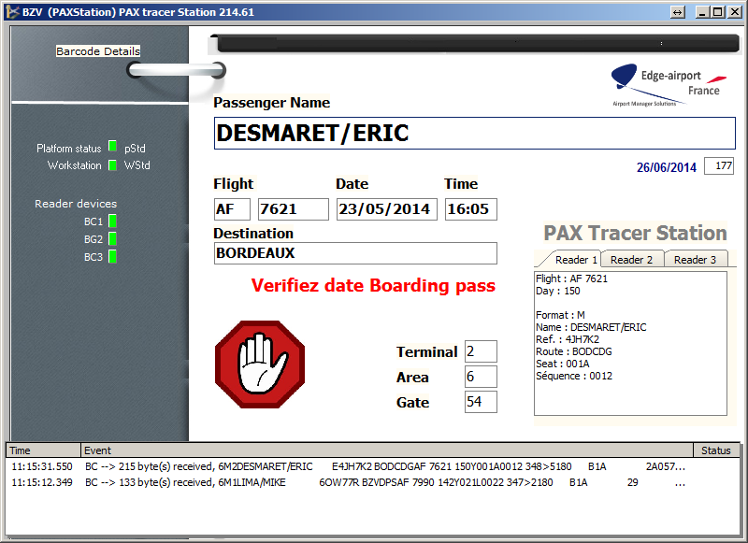

Gathering flight connections information

When the boarding card contains more than one multiple, they are saved in the database. In the example above, the final destination of the passenger is Bordeaux (BOD) via Paris Charles de Gaulle (CDG).

This allows to calculate statistics on the connections.

