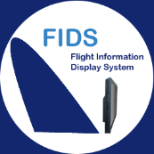

Airport Manager

FiDS

Flight Information Display System
- Flight Management:
  - seasonal flight schedules;
  - daily expected flight lists;
  - display all updates in real-time.

- Display functions:
  - domestic and international flight lists;
  - distribution of flights by information area in the airport;
  - customized display for airlines;
  - multimedia animations;
  - exporting flight information to be displayed on airport website (format XML et HTML).

- System management:
  - zoning and allocation of screens;
  - monitoring display screens remotely using FiDS Supervision.

Overview
Airport Manager FIDS is a user-friendly flight information display system based on HTML5 technology. It can be delivered with other modules of “Airport Manager” suite such as local-DCS, Cupp-T and aeronautical billing software.

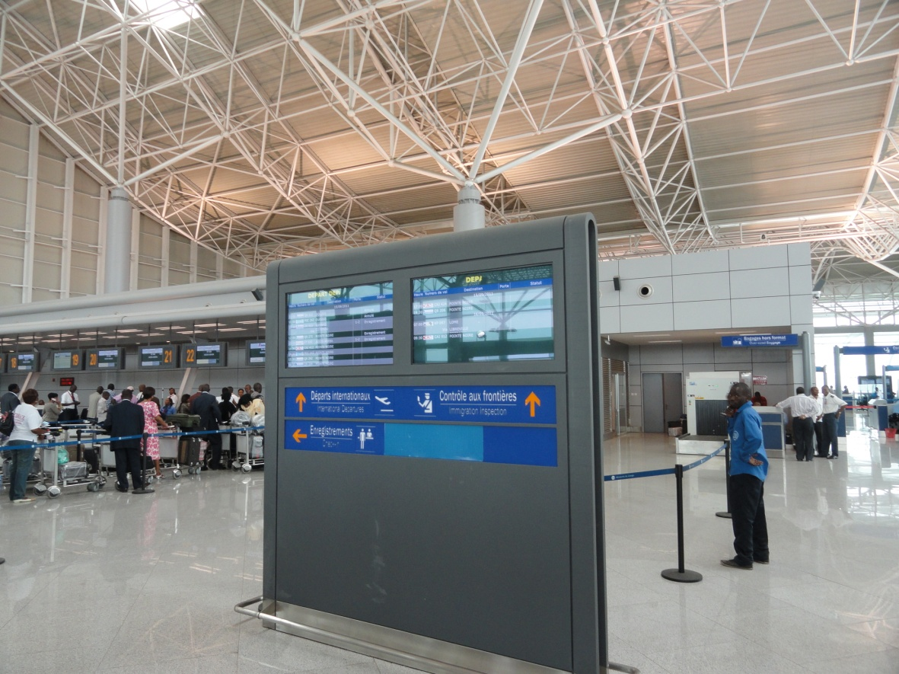

Advantages
Improving the passenger experience by providing the accurate flight information in real time : passenger service with accurate flight information:
- multilingual displays including Chinese, Arabic, French, English, etc.;
- exports flight information on airport website;
- facilitates system management by using supervision functions;
- reducing operating costs using automatically switching ON and OFF screens;

Flight control panel
- flight information (delayed, cancelled, etc.);
- arrival information (hall, baggage belt)
- departure information (check-in, gates, etc.).

Individual control panel
- sleep mode
- baggage belt, check-in, boarding
- flight arrivals and departures lists;
- sequence mode (selecting pages to be displayed in a loop);
- multimedia mode (broadcasting of videos or animations in internet format)

Examples of presentation

Flight arrivals information
Here is a sample FIDS deployed in Abidjan. It shows the planned flights in the evening and the first flight on the next day.
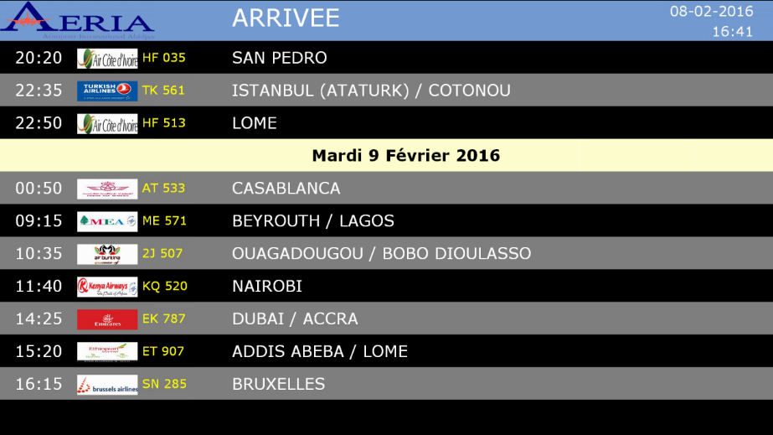

Passenger guidance information
In this example that is used in Pointe Noire, passengers are advised to follow one of three corridors leading to the boarding.
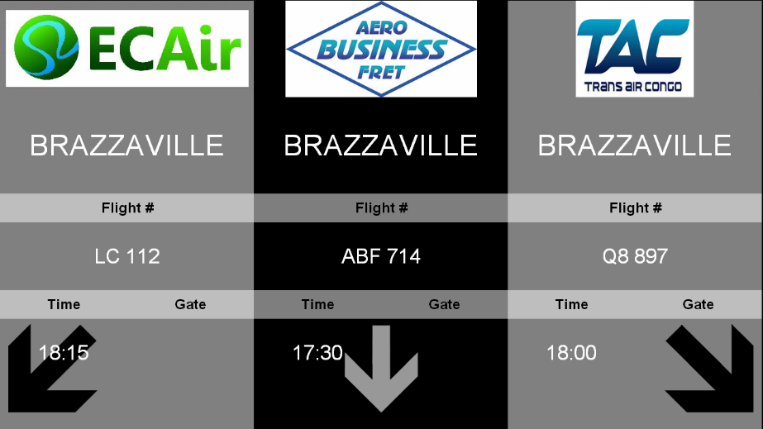

Check-in display for South African (SA)
FIDS allows to completely personalize the displays by airline company. It is possible to insert background images, video, scrolling text about flight information.
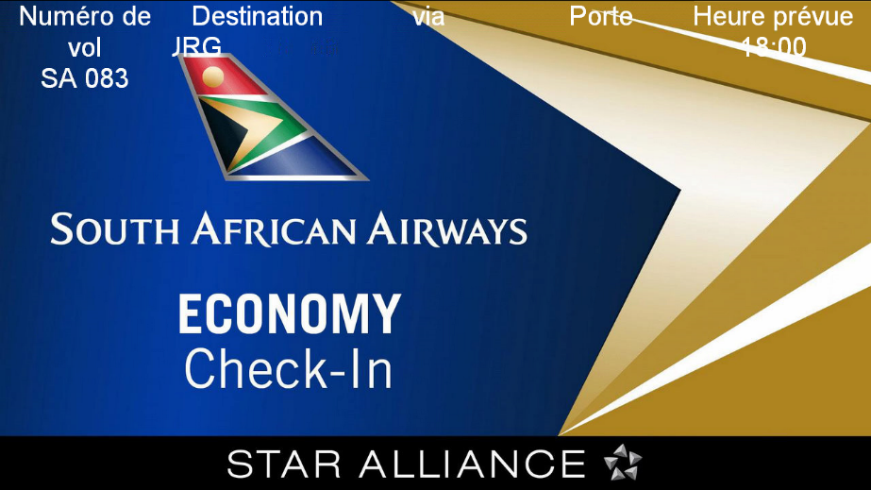

Check-in display default template
When there are no images or any special instructions provided by airlines, here is what is displayed by default:


Integration of Airport Manager FiDS with SSSP Samsung

Samsung Smart Signage Platform
The SSSP platform provides all-in-one solution that integrates a media player and PC with display management software. Equipped with powerful quad-core embedded System-on-Chip (SoC), the 2nd Generation Samsung Smart Signage Platform (SSSP) is much more enhanced with robust functionalities than ever.
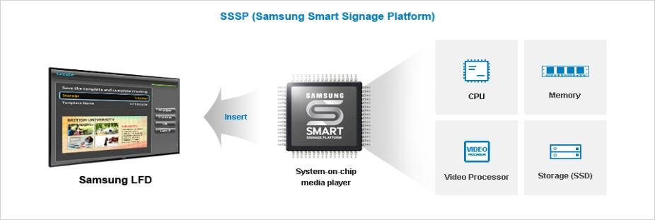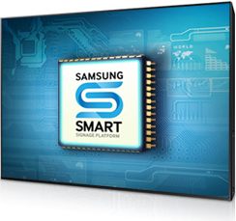
An all-in-one solution to offer a new display experience.
The "Samsung Smart Signage Platform" (SSSP) display solution is integrated in Samsung monitors, offering the power of a quad-core processor to use our different display solutions.
This new feature eliminates the need for an external PC while reducing the constraints of installation and maintenance. Using our FIDS, you can create, plan, and deploy your content effortlessly
Multiple types of content can be displayed simultaneously and continuously through quad-core processor, and 8GB to 16GB of storage.
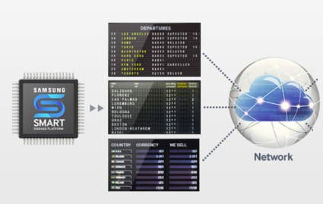

Easy installation with a ready-to-use solution
By integrating the media player into our solutions, SSSP technology allows for simple product integration and eliminates the costs of heavy installation. Finally, you no longer need an external PC or display software, which represents a real saving on your management fees and the purchase of the monitor.
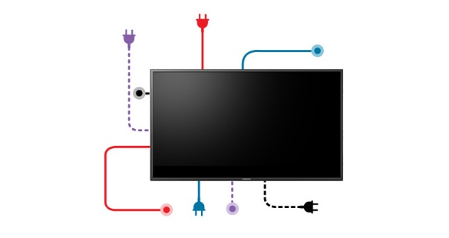
With SSSP you only need two cables to operate a Samsung monitor: a power cable and an RJ-45 cable.
Save money with an all-in-one Edge-Airport FIDS solution
Including all the elements necessary to achieve dynamic professional displays, Edge-airport solution significantly reduces costs by eliminating the need for an external PC and display software.
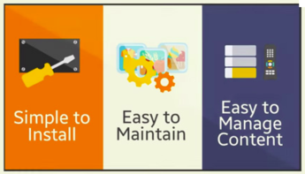
Our simple access solution allows airport to save costs for only few people are required to administer the system.
Lastly, by opting for all-in-one solution, you also save your energy consumption.

SuperVision FiDS
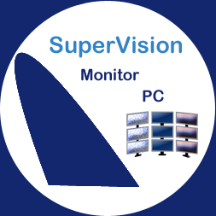
SuperVision allows real-time visualization of what is being displayed on screen allowing you to supervise all of the workstations and the display systems.
Compatible with Samsung SOC technology and Windows Player
The application,can take control of each screen and complete the following operations:
- stop / start;
- reboot;
- online indication;
- visualisation temps réel ;
- CUP and RAM usage;
- Programmable switch ON/ OFF times* ;
- remote control function* ;
- command line support**
*Solely on SOC Samsung technology
** Solely on Windows Player.

Example of supervision FIDS screen
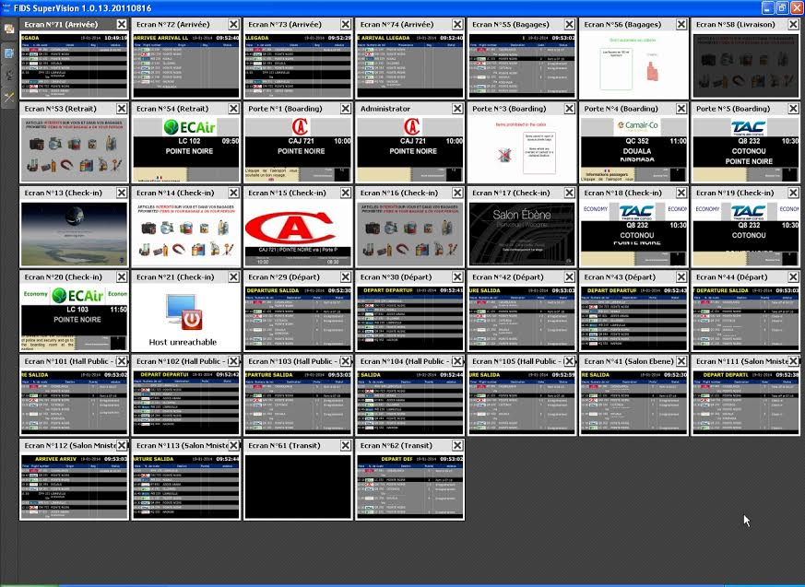

SuperVision allows administration of several platforms. It can be used in two modes for Edge-airport solutions:
- supervision of the Cupp-T system (IATA CUPPS platform);
- . supervision for FiDS , flight information display system.

