EN_EAF_PUB_AODB_201704-001_PlaqTech
Original file

AODB - Airport Operational DataBase

General Description
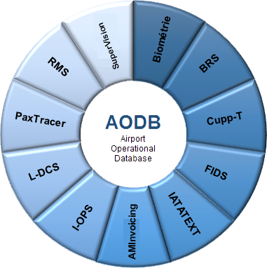
Airport Operational Database(AODB) is the central database or repository for all management systems. It provides all the flight related data in real time.
AODB is the “heart” of the airport. It allows integration and control of various airport systems such as resource allocation and billing into a single framework. Its management interface is user friendly, fast and easy to use.
AODB is the destination of all operational information generated automatically, or manually by external parties. Thus, the information is gathered in one source for all airport users and third parties.
In some airport networks, AODB can be deployed with a centralized system, allowing a single infrastructure serving several airports.

Features and advantages
- Real-time system:
  - A centralized information system that oversee all the events at airport in real time;
  - A centralized management of operations that allows real-time interaction with all systems.
- Robust and reliable system, using industry-standard technology, with mobile access capability.
- Air Traffic Control, Slot Assignment and Resource Allocation System.
- A unified, integrated and secure system, with a unique, friendly, fast, intuitive and central interface.
- Easy and effective administration of the user base and customization of group profiles allowing complete control over data access and updates.
- Modular system, allowing the airport to just acquire the necessary modules and simplifies architectures into a single infrastructure to reduce costs.

Functional features

Heart
Provides core functionalities of AODB such as:
- real-time management;
- system administration;
- information management;
- integration with external systems.

Scheduling
Functionality to generate a range of information in systems such as flight scheduling.

Planning
Deploying real-time operational information in the scheduling module such as flight planning.

Invoicing
This module provides functionality to invoice airlines for the use of airport resources.

Reports
to generate reports and identify indicators of different aspects of airport operations.

