FAQ : Cluster monitoring

Scope
Testing and Commissioning Procedure of Cluster

Description
A server cluster is composed of 2 rigorously identical servers configured in normal / backup high availability. The first server in normal mode is called “primary”, the backup server is called “secondary”.

Prerequisites
At a minimum, each server uses 3 network adapters configured as follows:
• ETH1 = Main Network Interface = IP_Server
• ETH2 = bridged network interface for virtual machines = IP_Br0
• ETH3 = “Private” server synchronization network interface, direct link between the cluster nodes.
On HP servers, the HP_ILO management interface for monitoring the machine can be set to benefit from the information of the server's physical state (see ILO monitoring documentation).
The 2 servers are connected to each other by a link allowing to have the servers in 2 different and distant technical premises to ensure the physical integrity of the equipment and the non-propagation of a physical damage on one of the two rooms.

CONNECTION SCHEMA
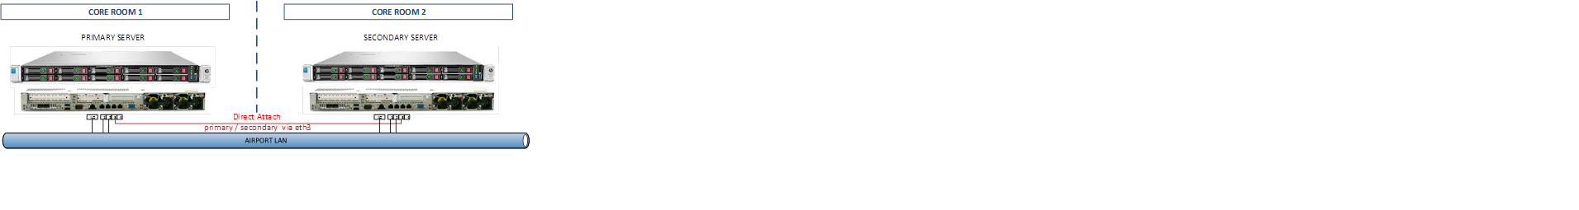

FUNCTIONING OF THE CLUSTER
The Linux services used for the Cluster are:
- Drbd = data replication between disk spaces
- Corosync = Configuration and scheduling of Cluster services
- Peacemaker = Monitoring cluster services
The services configured and monitored by the Cluster are:
- Apache = Web server
- MySQL = Database
- Samba = File Sharing
- Libvirtd = KVM Virtualization Engine
- Libvirtguest = Virtualization Management Tools
- IP Cluster / Route Cluster = Active Network Node
NOTE: All Linux services are controlled by Corosync, do not use the standard services of Linux daemons, do not use “services” or “systemctl” commands or automatic scripts like “samba”. Any activation of the services by this type of command cancels the system monitoring by peacemaker and corosync.

SERVER'S SUPERVISION WEB PAGE
Goto « http://ip_server/web/system/ezmonitor »
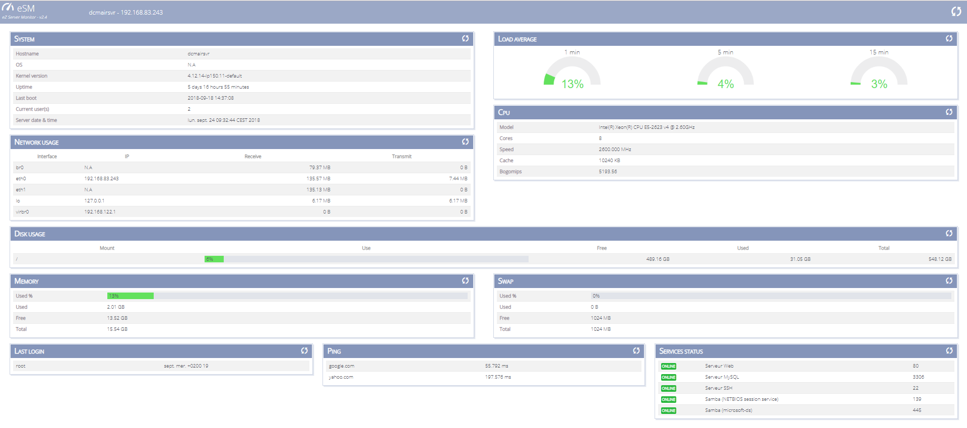

CHECKING THE SYNCHRONIZATION OF CLUSTER DATA
In a terminal or by ssh access on one of the cluster nodes use the “drbd-overview” command
Here the 2 primary and secondary servers are perfectly synchronized at the data level since the status “UpToDate” is effective on both servers.
Primary / Secondary Uptodate / Uptodate shows the synchronization status of the 2 nodes of the cluster.
In case the DRBD service is not started correctly (Cluster out of service), it is possible to restart the server data synchronization service via the following command:
# service drbdserv –full-restart

VALIDATION OF THE CORRECT FUNCTIONING OF THE CLUSTER (COROSYNC)
To know the state of the services managed by the cluster via a terminal or by access ssh, use the command “crm status”
The command returns the configuration and cluster status
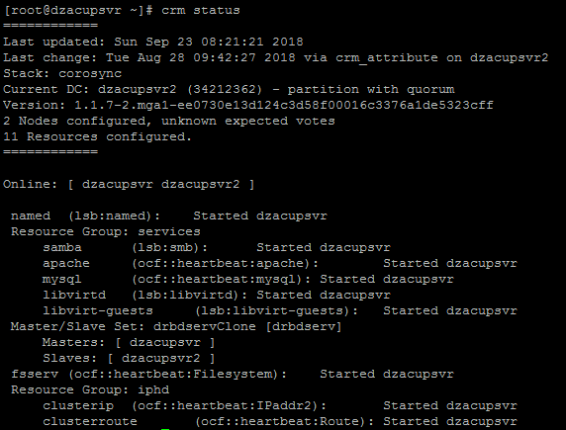

DESCRIPTION OF THE CONFIGURATION FILE
The first block indicates the state of the cluster

Last updated: Sun Sep 23 08:21:21 2018
Last change: Tue Aug 28 09:42:27 2018 via crm_attribute on dzacupsvr2
Stack: corosync
Current DC: dzacupsvr2 (34212362) - partition with quorum
Version: 1.1.7-2.mga1-ee0730e13d124c3d58f00016c3376a1de5323cff
2 Nodes configured, unknown expected votes
11 Resources configured.
The second block tells you which is the primary node, and where are the services:

Online: [ dzacupsvr dzacupsvr2 ]
Resource Group: services
samba (lsb:smb): Started dzacupsvr
apache (ocf::heartbeat:apache): Started dzacupsvr
mysql (ocf::heartbeat:mysql): Started dzacupsvr
libvirtd (lsb:libvirtd): Started dzacupsvr
libvirt-guests (lsb:libvirt-guests): Started dzacupsvr
Master/Slave Set: drbdservClone [drbdserv]
Masters: [ dzacupsvr ]
Slaves: [ dzacupsvr2 ]
fsserv (ocf::heartbeat:Filesystem): Started dzacupsvr
Resource Group: iphd
clusterip (ocf::heartbeat:IPaddr2): Started dzacupsvr
clusterroute (ocf::heartbeat:Route): Started dzacupsvr
⇒ the 2 servers are “online”, and each service is operational on the primary.

VERIFYING THE CORRECT FUNCTIONING OF THE CLUSTER
See the cluster configuration, use the following command:
# crm configure show
Example of a configuration file of the Abidjan cluster:
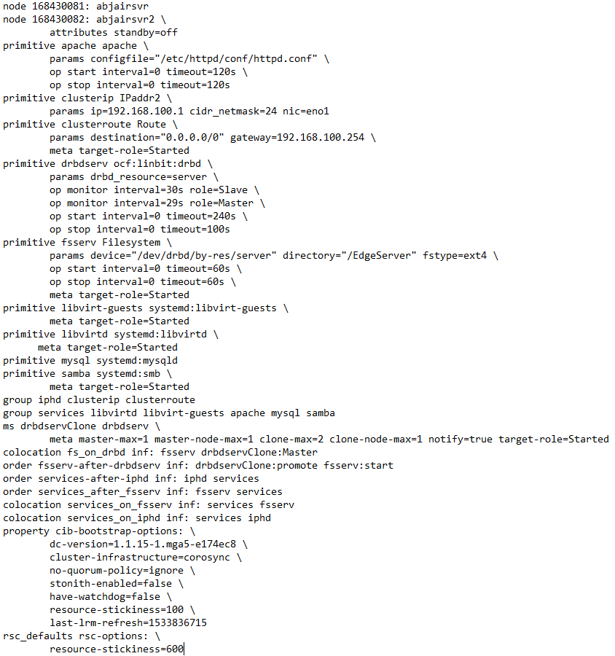

COmmands FOR VERIFYING THE CORRECT FUNCTIONING OF THE CLUSTER
for example « abjairsvr2 »
DESIRED Action | SYSTEM Command
Checking the cluster status | service corosync status
See cluster nodes | crm node
See the cluster configuration | crm configure show
Edit cluster configuration | crm configure edit
Put a cluster node in standby time to change a configuration | crm node standby abjairsvr2
Put back in service a node of the cluster (here secondary of abidjan) | crm node online abjairsvr2
Change a cluster configuration parameter | crm configure rsc_defaults resource-stickiness=100
View the status of a cluster service | crm resource libvirt-guests status
Purge a cluster service that does not start | crm resource cleanup libvirt-guests
Check whether or not a split brain exists (service that has migrated to a non-operational node) | grep “split-brain” /var/log/syslog
Move a service from one node to another (in the case of a split brain) | crm resource move libvirt-guests abjairsvr2
Reattach a service to the cluster | crm resource manage libvirt-guests
Check that the configuration files are identical between the nodes of a server | crm cluster diff /etc/samba/smb.conf

VERIFICATION OF CLUSTER MANAGEMENT TOOLS
DESIRED Action | SYSTEM Commands
See cluster nodes | systemctl status pacemaker
See the cluster configuration | systemd-analyze verify pacemaker.service
Edit cluster configuration | systemctl pacemaker.service reload
Put a cluster node in standby time to change a configuration | systemd-delta pacemaker.service
Put back in service a node of the cluster (here secondary of abidjan) | journalctl -u pacemaker | more

