Cupp-T - IATA CUPPS Platform


IATA CUPPS Platform

Common Use Passenger Processing Technology
IATA recommended practice 1797
- Security:
  - authentication of the users;
  - only applications authorized by the platform can be run;
  - secure access to printers, boarding card readers and other peripherals.
- Interoperability & compatibility:
  - portable applications Load and Play (LnP);
  - web hosted applications;
  - permits the use of peripherals without proprietary firmware.
- IATA / CUPPS certified

General
Cupp-T is a high-performance platform which facilitates airlines, ground handlers or other operators to share common physical check-in, gate or back and front-office positions, and the associated peripherals, improving the efficiency of airport resources.
Airport Manager Cupp-T supports any CUPPS compliant application including but not limited to:
- DCS (Departure Control System) for airlines;
- Local-Departure Control System like Airport Manager L-DCS;
- Back office Applications;
- Other Operational Applications.
Certified to IATA / CUPPS version 01.03 revision 9.
Supports the all major DCS for airlines:
- ALTEA ©Amadeus
- GAETAN ©Air France
- Lufthansa Cute Future ©Brussels Airlines
- MACS © Emirates
- TROYA © Turkish Airlines
- Local DCS Airport Manager used by Air Corsica and many lowcost airlines like Ryanair, flyBE, Transavia, EasyJet, etc
- all DCS applications conforming to the IATA / CUPPS norm.

Simple to Use Interface
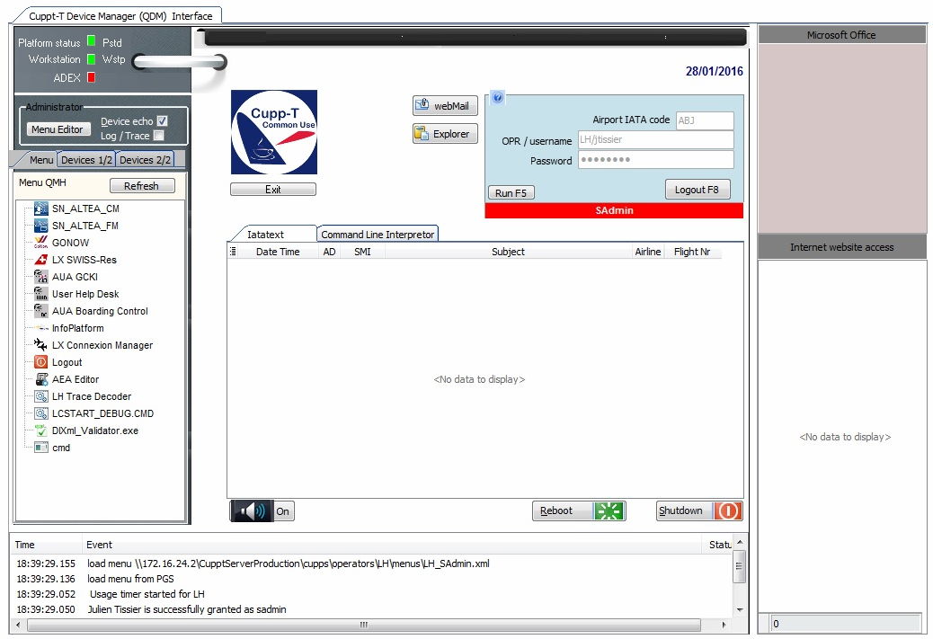
Cupp-T: A modern and secure interface. In secure mode, only administrators have access to ‘Windows' desktop.

Features
In addition to hosting airline applications, Cupp-T offers advanced functions:
- launching Microsoft office applications – Word, Excel, PowerPoint, etc.;
- controlled access to a list of websites defined by the system administrator;
- dynamic creation of multiple menus per operator and per user group;
- controlled access to webmail;
- configuring devices in just a few clicks.

Configuring Peripherals
Cupp-T allows system administrator to manage the devices.
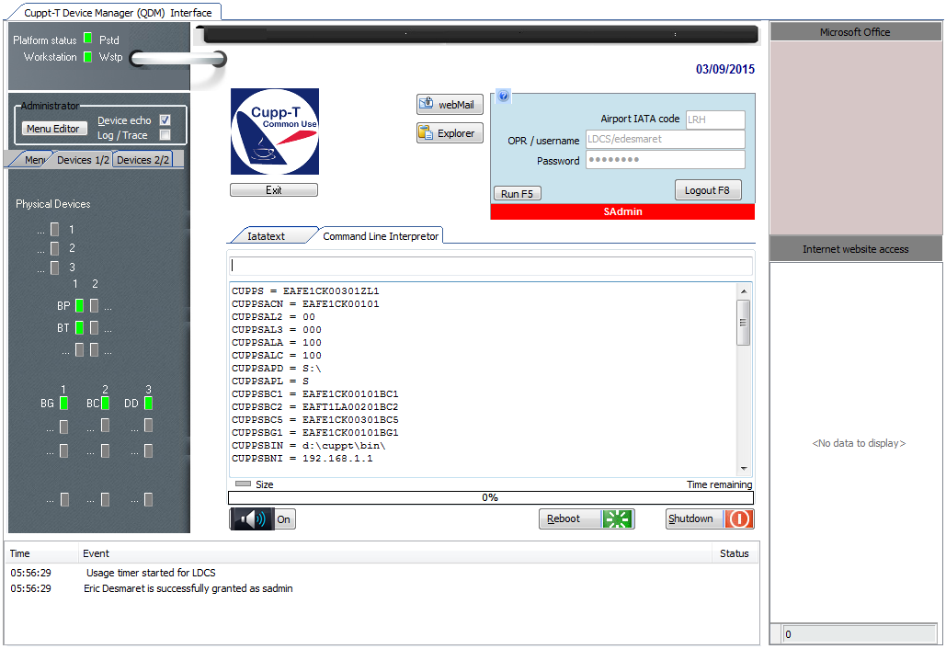

Naming standard of peripherals as per IATA/CUPPS norm
BP | Boarding Pass Printer | MS | Magnetic Swipe reader
BT | Bag Tag Printer | OC | Optical Character reader
BG | Boarding Gate reader | PR | Document Printer
BC | Bar Code Reader
DD | Display Device
The configuration of a device takes a few clicks using the following window:
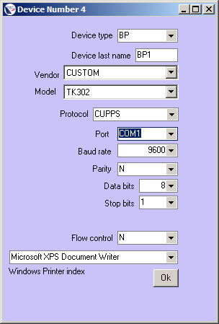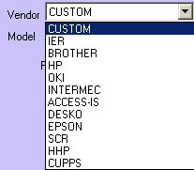
Just select a vendor and model from the list of CUPPS certified hardware to add or replace a device (Boarding pass or boarding tag printer, passport reader, magnetic card reader, etc.).

Competitive opening
Cupp-T does not use proprietary firmware for the devices. Thus, when the hardware needs to be replaced, the airport management has the full freedom of choice for any device vendor or model they intend to buy.

Example of ALTEA
In the example below, the departure control application “ALTEA DC“ is launched by Cupp-T.
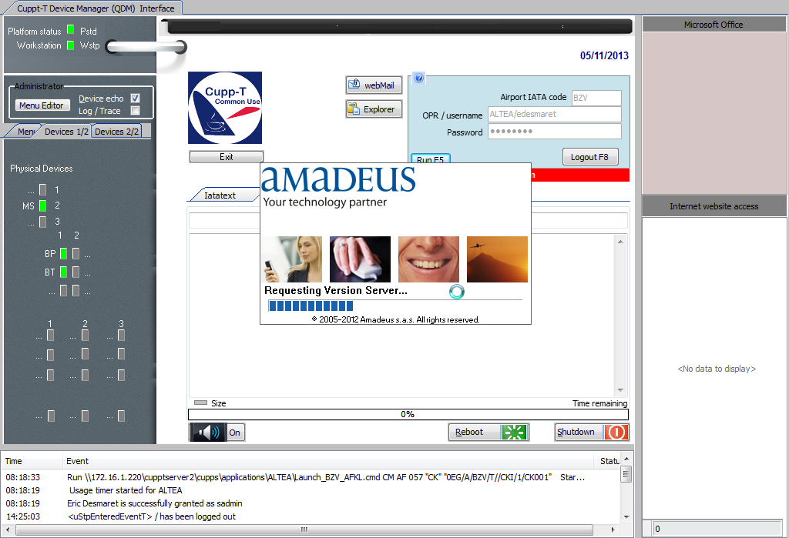

SuperVision

Supervision Station
In Back Office, SuperVision allows IT staff to monitor the correct functioning of each workstation and running applications on Cupp-T platform. workstation.
The tool can take control of each screen and complete the following operations:
- stop;
- restart;
- remote control for technical support and training purposes;
- monitoring of
- processes and memory resources
Example of CUPPS
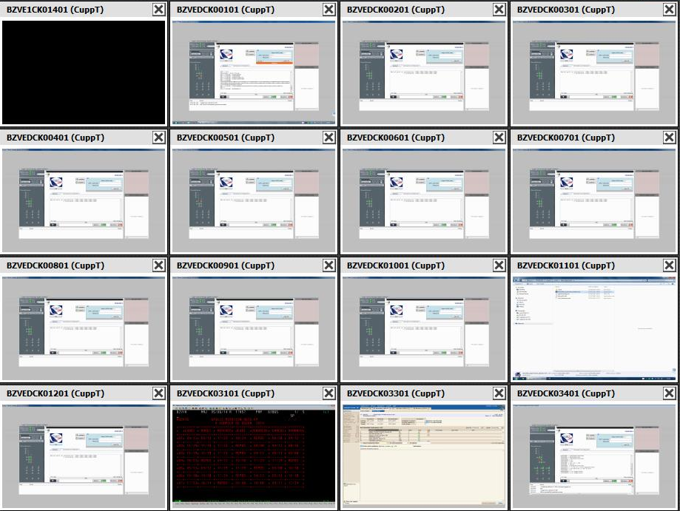
SuperVision allows administration of several platforms. It can be used in two modes for Edge-airport solutions:
- supervision of the Cupp-T system (IATA CUPPS platform);
- supervision for FiDS , the flight information display system.

