BRS - Baggage Reconciliation System
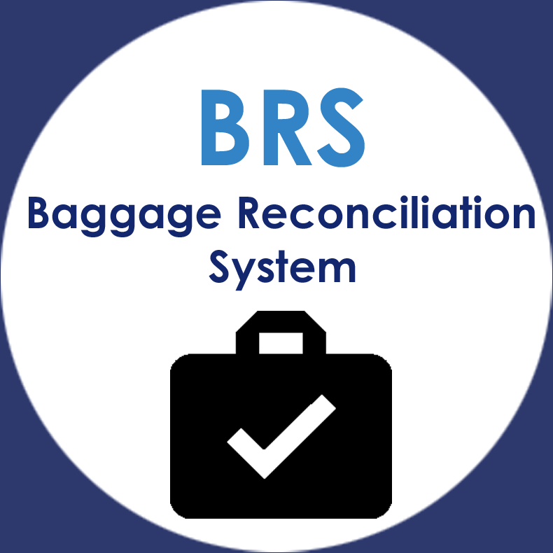

BRS (Baggage Reconciliation System) is a complete system of reconciliation and baggage tracking. It enables a better service to airlines and airports by improving the safety, speed and traceability of luggage.
Based on the latest technologies, it allows to trace each checked or in –transit baggage, with a corresponding flight and passenger.
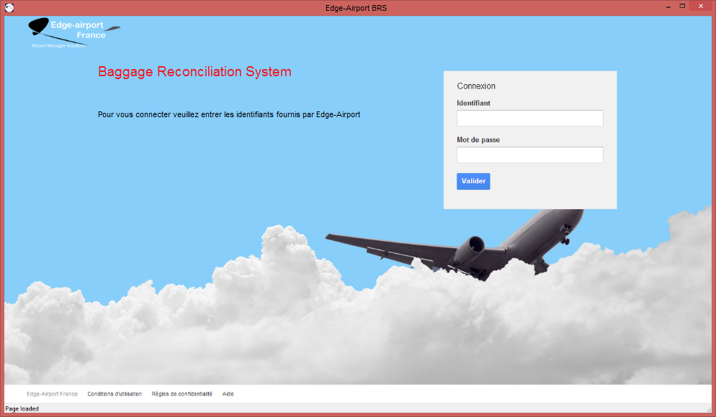

Baggage information management
BRS allows the retrieval of baggage and passenger information for any airline which sends baggage messages (IATA standard). It ensures the correspondence between baggage and flight information received by AODB and allows the baggage tracing throughout its journey. BRS can send baggage messages to airlines at any time (tracking and manifest).

Mobile terminal
Through the use of mobile terminals with bar code scanners, baggage handlers have access to real-time information and provide assistance in locating baggage, loading and unloading containers (ULD, Unit Load Device), etc.
They can also work in offline mode (for distant parking spaces).
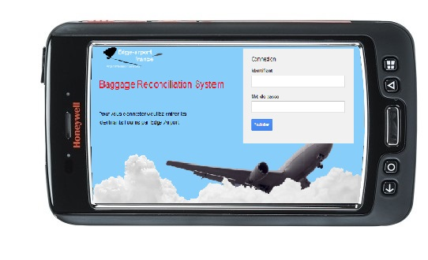

Workstation
BRS workstation allows supervisors to assign a container, to monitor the progress of baggage loading, baggage cancellation, reprint damaged baggage tag and perform follow-up operations and reconciliation of luggage. They can also print baggage manifest at any time.

Functional Architecture
The BRS is composed of different modules :
- an IATATEXT interface, to receive and send baggage messages :
  - BCM Baggage Claim Message,
  - BSM Baggage Status Message,
  - BTM Baggage Transfer Message,
  - BUM Baggage Unload Message;
- an AODB interface, for coupling the baggage messages with the flight information;
- a database server that links the baggage information with the passenger data.
A web server that distributes information to client stations (PDAs, workstations, displays …).


