Supervision : User Guide

Introduction

Objective
Edge Supervision allows real-time visualization of what is being displayed on the screen allowing you to supervise all of the workstations and the display systems. This mosaic, fully configurable, allows users to view live all the connected PCs and screens and set the thumbnail view to regroup stations by function, location, type. It is also possible to take control of each screen remotely, independently of the others, in order to perform a manual action if necessary. 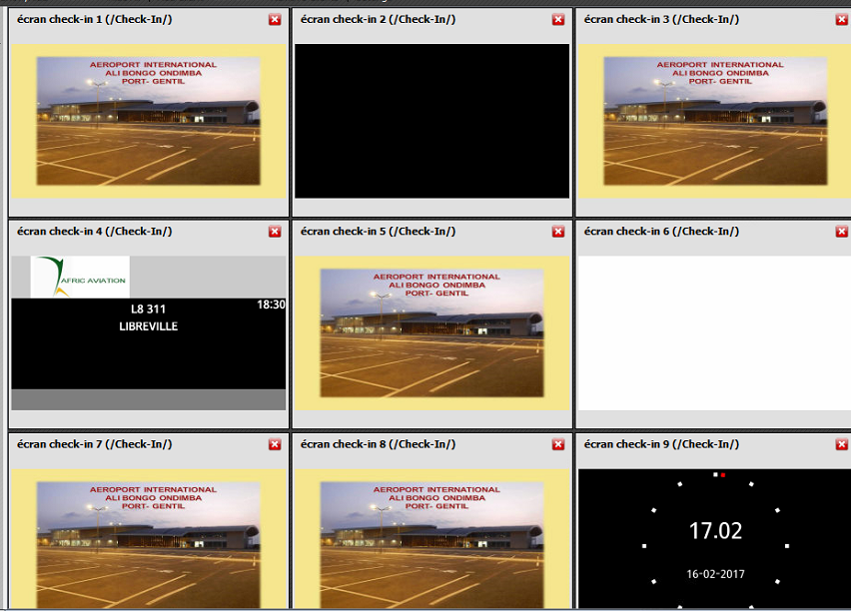

Description of the user interface
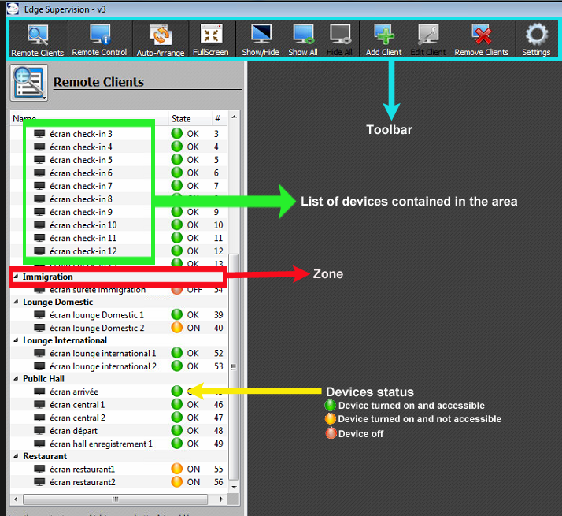
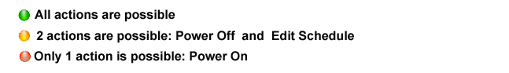

Viewing the display devices

Displaying device content
- Click Show All on the menu bar.
- A mosaic of contents appears on the screen.
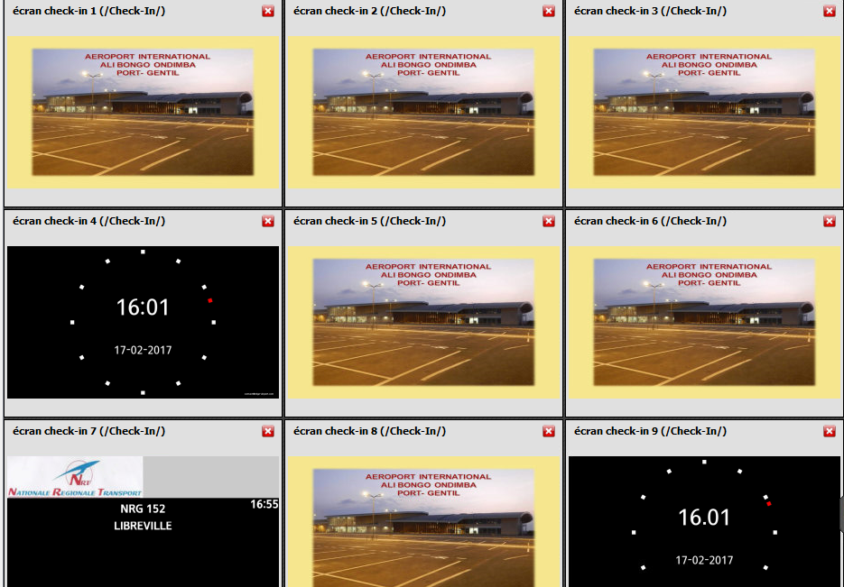

Removing screensMosaic
- Click Hide All on the menu.

Managing zones

Turning on devices within a zone
- Right click on the name of the zone to be switched on.
- Position the mouse on Remote Client Actions.
- Click on Power on in the context menu.
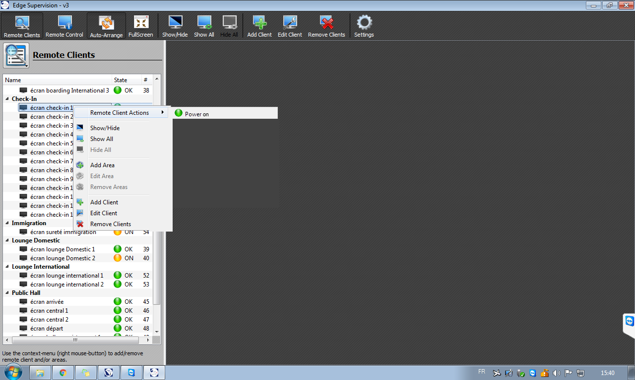

Restarting devices in a zone
- Right-click on the name of the zone to be restarted.
- Position the mouse on Remote Client Actions in the menu which appears
- Click on Restart in the context menu.
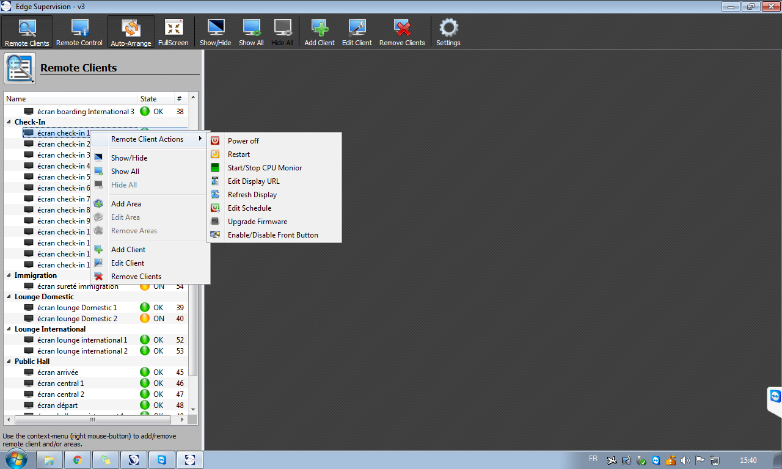

Switching off devices in a zone
- Right-click on the name of the zone to be switched off.
- Position the mouse on Remote Client Actions.
- Click on Power off in the context menu.

Adding the area
- Right-click in the screen area.
- Click on Add Area in the menu that appears.
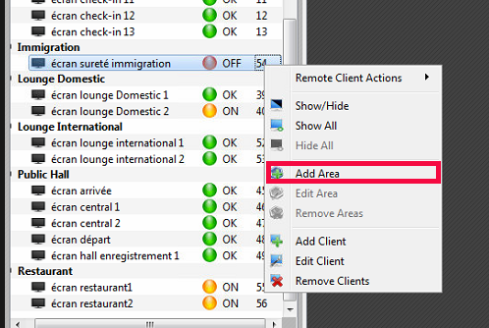
- Enter name for a new zone in the Name field of the Dialog window.
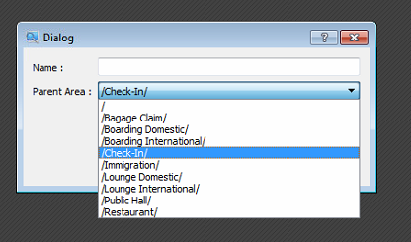

Creating a parent area
- Click on/in the Dialog window:
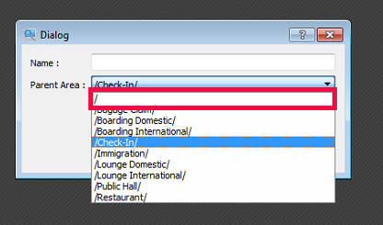
- Click on OK to confirm.

Creating a child area
A child area is a zone that is dependent on another zone.
- Click on one of the existing zones.

- Click on OK to confirm.

changing the placement of a zone
- Right-click in the area you want to change.
- Click Edit Area in the context menu.

- The Dialog window opens:

- Type the new name of the zone in the Name field.
- Click on the Parent Area dropdown arrow to change its location.
- Click OK to confirm.

MANAGING THE DEVICES

TUrning on A device
- Right-click on the device to be switched on.
- Position the mouse on Remote Client Actions.
- Click Power on in the context menu.

restarting a device
- Right-click on the device to be restarted.
- Position the mouse on Remote Client Actions in the menu which appears
- Click on Restart in the context menu.

turning off a device
- Right-click on the device to be switched off.
- Position the mouse on Remote Client Actions in the menu which appears.
- Click on Power off in the context menu.

Viewing display of the devices
- Click on the relevant device.

- Click Show / Hide in the menu bar.
- The contents are displayed.

programming on/off times of samsung soc screens
- Right click on the device to be programmed.
- Position the mouse on Remote Client Actions in the menu which appears.
- Click on Edit Schedule in the contextual menu.
- The Edit Schedule window opens.
- Check mark the Power On to set the time at which the device should turn on.
- Fill out the fields below.
- Check mark the Power Off box to set the time at which the device should turn off.
- Fill out the fields below.
- Click OK to confirm.

Adding a device
- Right-click on the screen area.
- Click on Add Client in the menu that appears.
- The Select a Remote Client window opens:

Adding a samsung soc screen
- Click on SoC Samsung in the Select a Remote Client window.

- The Remote Client window opens:

- Complete the fields.
- Click OK to confirm.

Adding a computer
- Click on VncComputer in Select a Remote Client window.

- Click on OK.
- The Dialog window opens :

- Complete the fields.
- Click OK to confirm.

CHANGING THE DEVICE
- Right click on the device to be edited.
- Click on Edit Client in the menu which appears.
- The Remote Client window opens :

- Modify the necessary fields.
- Click OK to confirm.

Deleting a device
- Right-click on the screen area.
- Click on Remove Client in the menu which appears.
= End of the user manual. =

